August | 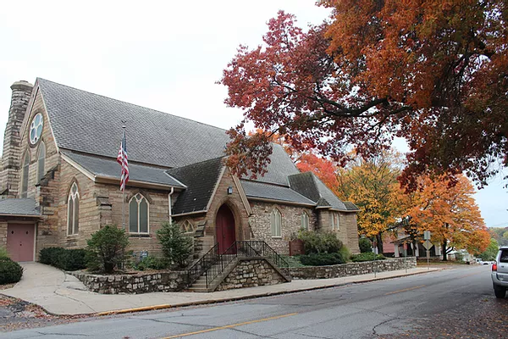
 | 2022
Sunday | Monday | Tuesday | Wednesday | Thursday | Friday | Saturday
 | 1 | 2 | 3 | 4 | 5 | 6
 | PCC 10:00a.m. |  |  | PEO Bridge 1:00p.m.-3:00p.m. |  | F.I.S.T 9:00a.m.-12:00p.m.
7 | 8 | 9 | 10 | 11 | 12 | 13
 |  |  | Book Club 6:30p.m. |  |  | Community Meal 11:00a.m.-1:00p.m.
14 | 15 | 16 | 17 | 18 | 19 | 20
 |  | Vestry 6:30p.m. | Men’s Group 9:00a.m. | PEO Bridge 1:00p.m.-3:00p.m.
21 | 22 | 23 | 24 | 25 | 26 | 27
28 | 29 | 30 | 31

