January | 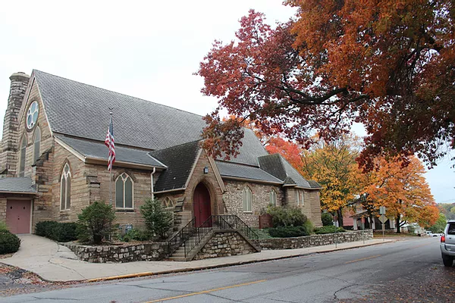
St. Paul’s Episcopal Church | 2022
Sunday | Monday | Tuesday | Wednesday | Thursday | Friday | Saturday
 |  |  |  |  |  | 1
New Year’s Day
No F.I.S.T.
2 | 3 | 4 | 5 | 6 | 7 | 8
Service 9:30a.m. | Office closed for New Year’s Holiday | Minster Meeting  6:00p.m. |  | Choir 7:00p.m. |  | Community meal  11:00a.m.-1:00p.m.
9 | 10 | 11 | 12 | 13 | 14 | 15
Service 9:30a.m. |  |  |  | Choir 7:00p.m.
16 | 17 | 18 | 19 | 20 | 21 | 22
Service 9:30a.m. |  | Vestry meeting  5:30p.m. |  | Choir 7:00p.m.
23 | 24 | 25 | 26 | 27 | 28 | 29
Service 9:30a.m.  Vestry Annual Mtg  10:30a.m. |  |  |  | Choir 7:00p.m.
30 | 31
Service 9:30a.m.

