May | 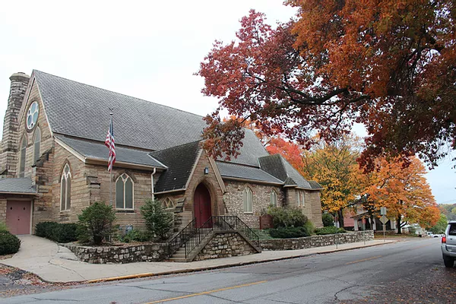
St. Paul’s Episcopal Church | 2022
Sunday | Monday | Tuesday | Wednesday | Thursday | Friday | Saturday
1 | 2 | 3 | 4 | 5 | 6 | 7
 | Minster Group 6:00 p.m. |  |  | Choir 7:00 p.m. |  | F.I.S.T. 9:00 a.m. –  12:00 p.m.
8 | 9 | 10 | 11 | 12 | 13 | 14
 |  |  |  | Choir 7:00 p.m. |  | Community Meal  11:00 a.m. – 1:00 p.m.
15 | 16 | 17 | 18 | 19 | 20 | 21
 |  | Vestry 5:30 p.m. | Men’s Group 9:00 a.m.  Book Club 6:30 p.m. | Choir 7:00 p.m.  P.O.E. Bridge 1:00 p.m.
22 | 23 | 24 | 25 | 26 | 27 | 28
 |  |  |  | Choir 7:00 p.m.
29 | 30 | 31
Memorial Day
Office Closed for
the Holiday

